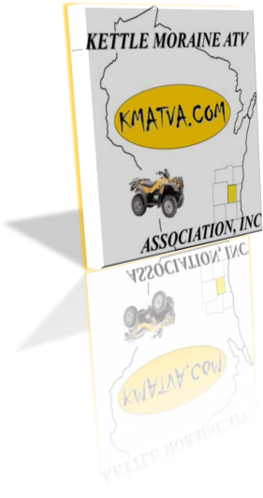
KETTLE MORAINE ATV
ASSOCIATION, INC.
general meeting minutes
prepared by: Tim Rohrer, President
july 11, 2013
Members Present:

Tim Rohrer Robin Dorzok Kenn Ziebell John Roller JoAnn Roller Pat Skarie

Rick Skarie Dave Derrick Linda Derrick Rick Welch Ron Knier Roberta Knier

Peter Boldt Laura Boldt Terry Kolbach Marvin Kolbach Jayne Kolbach

Mike Desterhoft Julie Desterhoft Mike McKenna Kevin Sabel

- Call meeting to Order
  - Meeting was called to order at 7:50pm

- Pledge of Allegiance lead by Kenn Ziebell

- Approval of Minutes
  - Motion by Marvin Kolbach, seconded by Kevin Sabel, that the general meeting notes from June be approved. Motion passed.

- Introduction of New Members
  - None

- Special Presentations
  - None

- Reports from Executive Committee
- Board of Directors
- President
- Vice President
- Secretary
- Treasurer
  - Treasurer’s report was reviewed and filed.
  - Motion by Dave Derrick, seconded by Kenn Ziebell, that the Treasurer’s report from June be approved. Motion passed.
- Advisors (WDNR-RSW or WATVA)

- Reports from Committees
- Business relations committee – JoAnn
  - JoAnn discussed attending a Chinooks baseball game as a group. The Chinooks are a minor league baseball team in Mequon. The Chinooks donate for our Cancer Ride.

- Fund raising committee – JoAnn
  - JoAnn also advised that we have had BBQ ribs donated for Saturday night’s meal for the Cancer Ride. Please bring a dessert if you’re attending. Carol will also be donating brats and hot dogs for Friday night’s meal.

- Planned rides committee – JoAnn/Tony
  - The remainder of this year’s planned activities calendar was reviewed. (Check schedule on our website.)

- Old and Unfinished Business

  - Sign for Mountain Springs – JoAnn/Robin
    - Robin brought the sign for Mountain Springs Motel. The sign was designed to promote the motel supporting the Cancer Ride annually, the second weekend in October. Robin delivered the sign and Bob/Carol will be placing it up soon.

  - Plymouth Races – Robin
    - Robin received a $500.00 check for our time working the vendor stands at the Plymouth race track. Thank you to everyone who worked the stands. This is an easy way for us to boost our finances.

  - County Fair July 23-28th-JoAnn/Connie
    - We will again be working the Washington County Fair. Cedar Creek Motorsports and Fuel Powersports are allowing us the opportunity to use their space to promote our club. Thank you to Cedar Creek and Fuel for allowing us this opportunity.

  - Motorcycle Charity Race-August 24th
    - JoAnn has talked to Scott about the races. Scott indicated he appreciated our help with the races. Proceeds from this event also help Chix 4 a Cause. Please watch for more information on this event if you plan on attending and helping. If you do plan on helping, remember we can bring our ATV’s to patrol the race track. If you’re not interested in patrolling the track, we will also have a booth promoting the club that we could use help with.
- New Business
  - Bumper Stickers.
    - Robin brought a bumper sticker that was discussed. The cost of the bumper sticker was $8.00. It was decided that the price for the bumper sticker was too expensive for us at this time
  - Not for Profit status
    - Dave D asked why we were not a not for profit organization. Dave indicated that he would check with the IRS. Since the meeting, Dave sent Tim paperwork for not for profit status. Tim is collecting some of the information for the application.
  - July Meeting
    - Rick suggested that we hold our July meetings the second Thursday of the month at Sandy Knoll County Park every year as we did this year. Thank you to everyone that brought food and beverages to this year’s picnic meeting.

- Raffle

- General Announcements/Rides

- Establishment of next meeting date, time and location
  - The next meeting will be at 7:00pm on Aug 1, 2013 at Lighthouse Lanes in West Bend, WI.

- Adjournment
  - Motion by Kenn Ziebell, seconded by Marvin Kolbach, to adjourn the meeting. Meeting adjourned.

